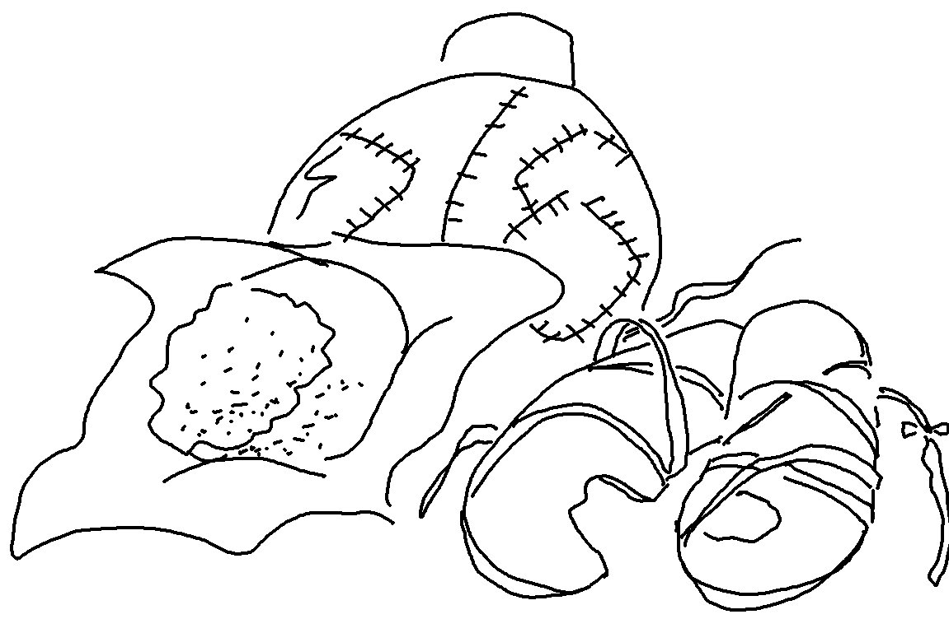
The Lord detests lying lips, but He delights in those who
tell the truth.
Proverbs 12:22_{NLT}

